***Smart phone controlled light system.***

***Circuit diagram:***

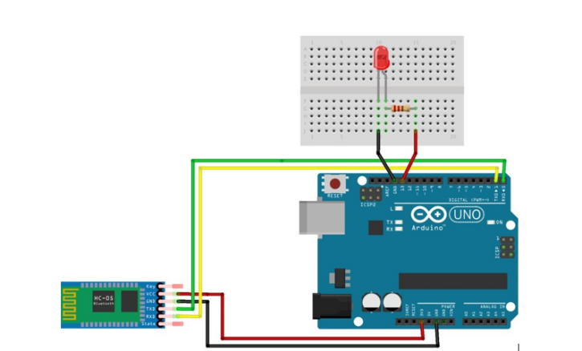

***THEORY:***

***Concept Used:-***

***In this project we have used concept of Bluetooth that enables us to control the led on breadboard with our respective mobile smart phones with give and take of signals .Through this we can have access to any module with our mobiles(smart phones).***

***LEARNING AND OBSERVATIOBS:***

***Learnings: -***

* ***How to make use of Bluetooth .***
* ***To do coding on Arduino software as well on tinkercad.***
* ***Compiling and uploading codes done on tinkercad.***
* ***Use of tinkercad for making hardware and software .***
* ***Use of breadboard and to make and execute circuits on it.***

***Observations: -***

* ***Working of a software on tinkercad.***
* ***Lightning of led when commanded by our smart phones.***
* ***Software and hardware used for making circuit.***

***PROBLEMS AND TROUBLESHOOTING:***

* ***Uploading and compiling of codes.***
* ***Checking connections and underlining defective Bluetooth or error while giving commands by our smart phones .***
* ***Checking correct port for software on tinkercad and type of Arduino.***
* ***Correct working of various hardware and software used.***

***Precautions:***

* ***Don’t make loose connections.***
* ***Don’t connect Arduino to the respective pc until the circuit is complete.***
* ***Carefully look on the working of all the devices used while making circuit.***
* ***Carefully look on the working of Bluetooth and smart phones.***

***Outcomes:***

* ***The circuit is complete and ringing of lightning of led when command is given by smart phones.***
* ***Can be used also for security purpose at many places.***